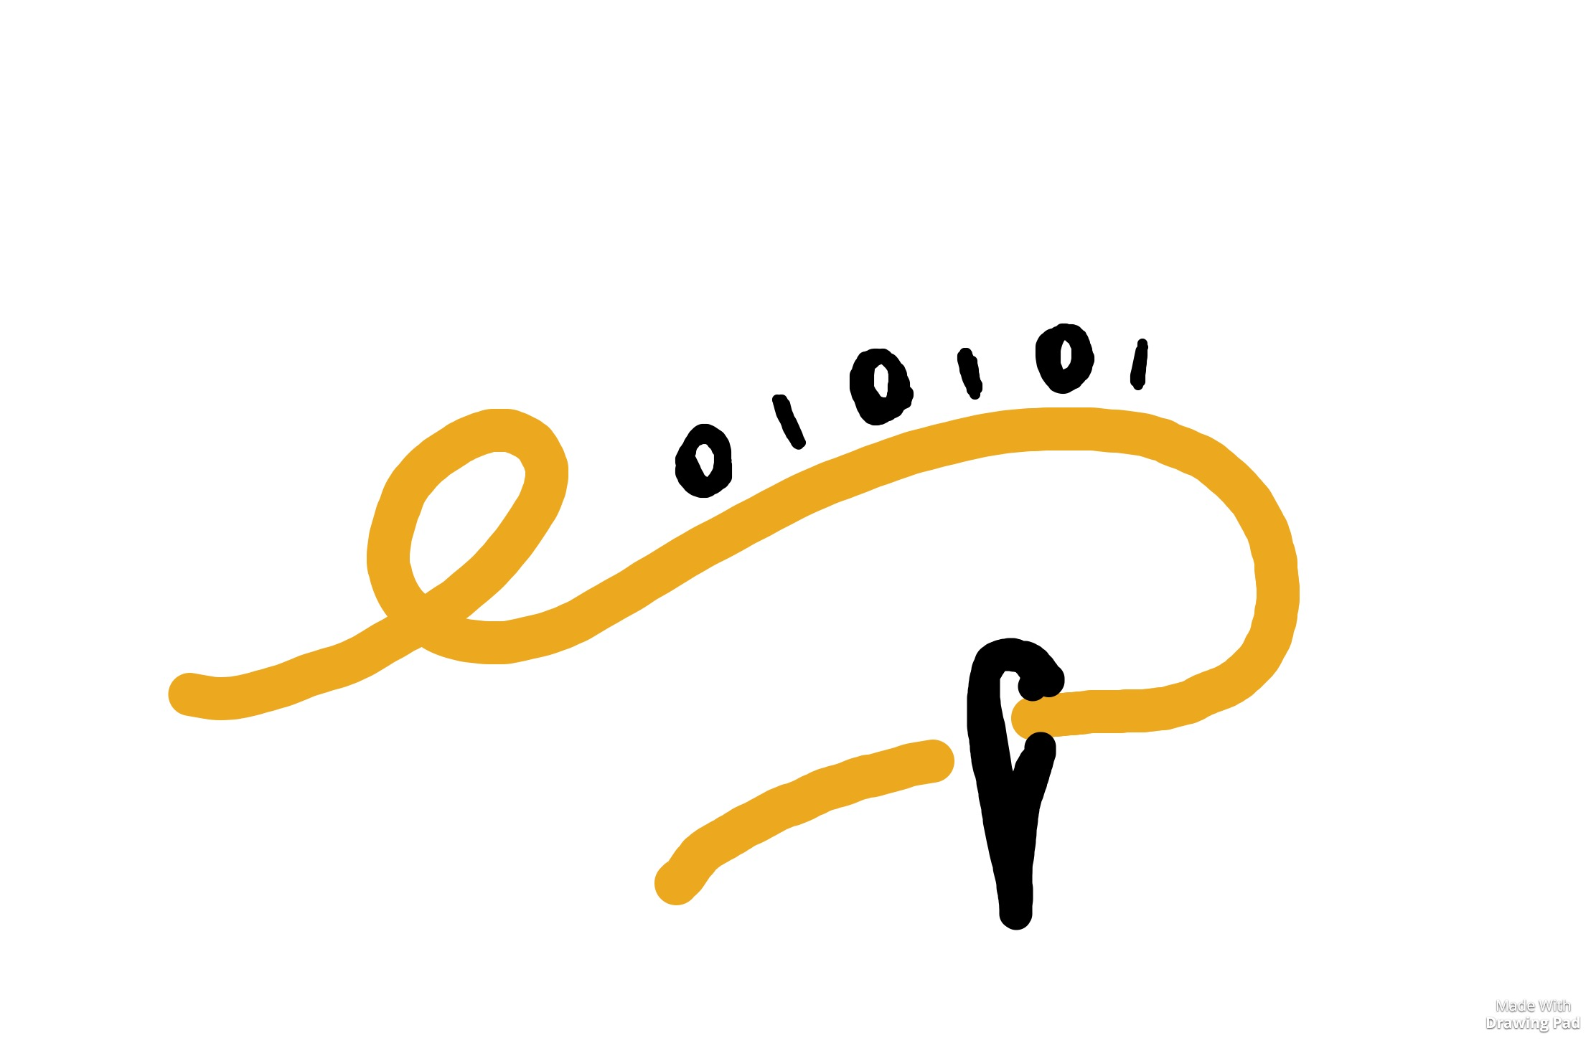

**Introduction to Data Weaving**

Saturday March 2nd, 3:00pm - 3:50pm

Room 619, Bobst Library

70 Washington Square South

**Event Description**

The origin of the algorithms goes back further than the creation of the computer. Heros like Annie Albers and Gertrude Preiswerk were weaving patterns at the Bauhaus akin to computational outputs well into the early 1940’s. Today, with the popularity of data visualization, many modern weavers are incorporating basic code into their practice as a way to embed and encode messages or information into their textiles.

In this beginner friendly workshop, you’ll learn how to take a simple phrase and turn it binary to create a digital patterns. Then, on a laser cut pocket loom, you’ll learn the basics of weaving in order to translate your data from the screen to the skein. Each participant will leave with a woven data project and their own loom!

This workshop was taught by Ashley Jane Lewis presented as a final project for [Teaching as Art](https://urldefense.proofpoint.com/v2/url?u=https-3A__teachingasart.github.io_posts_teachingasartday_&d=DwMFaQ&c=slrrB7dE8n7gBJbeO0g-IQ&r=s8U-k8IzhlY_Te7DoYrGJw&m=wFsCJ6UViOBGeWRb1A3oTu-tD8x_ZaCpqDppKh7si0w&s=dYHjM_uobDpToRoaZuVCB2pAyhglE52HrzOMoCcOipc&e=) class at NYU ITP.

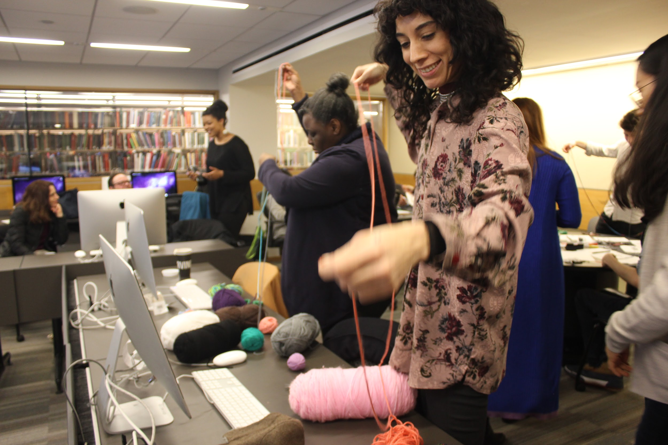

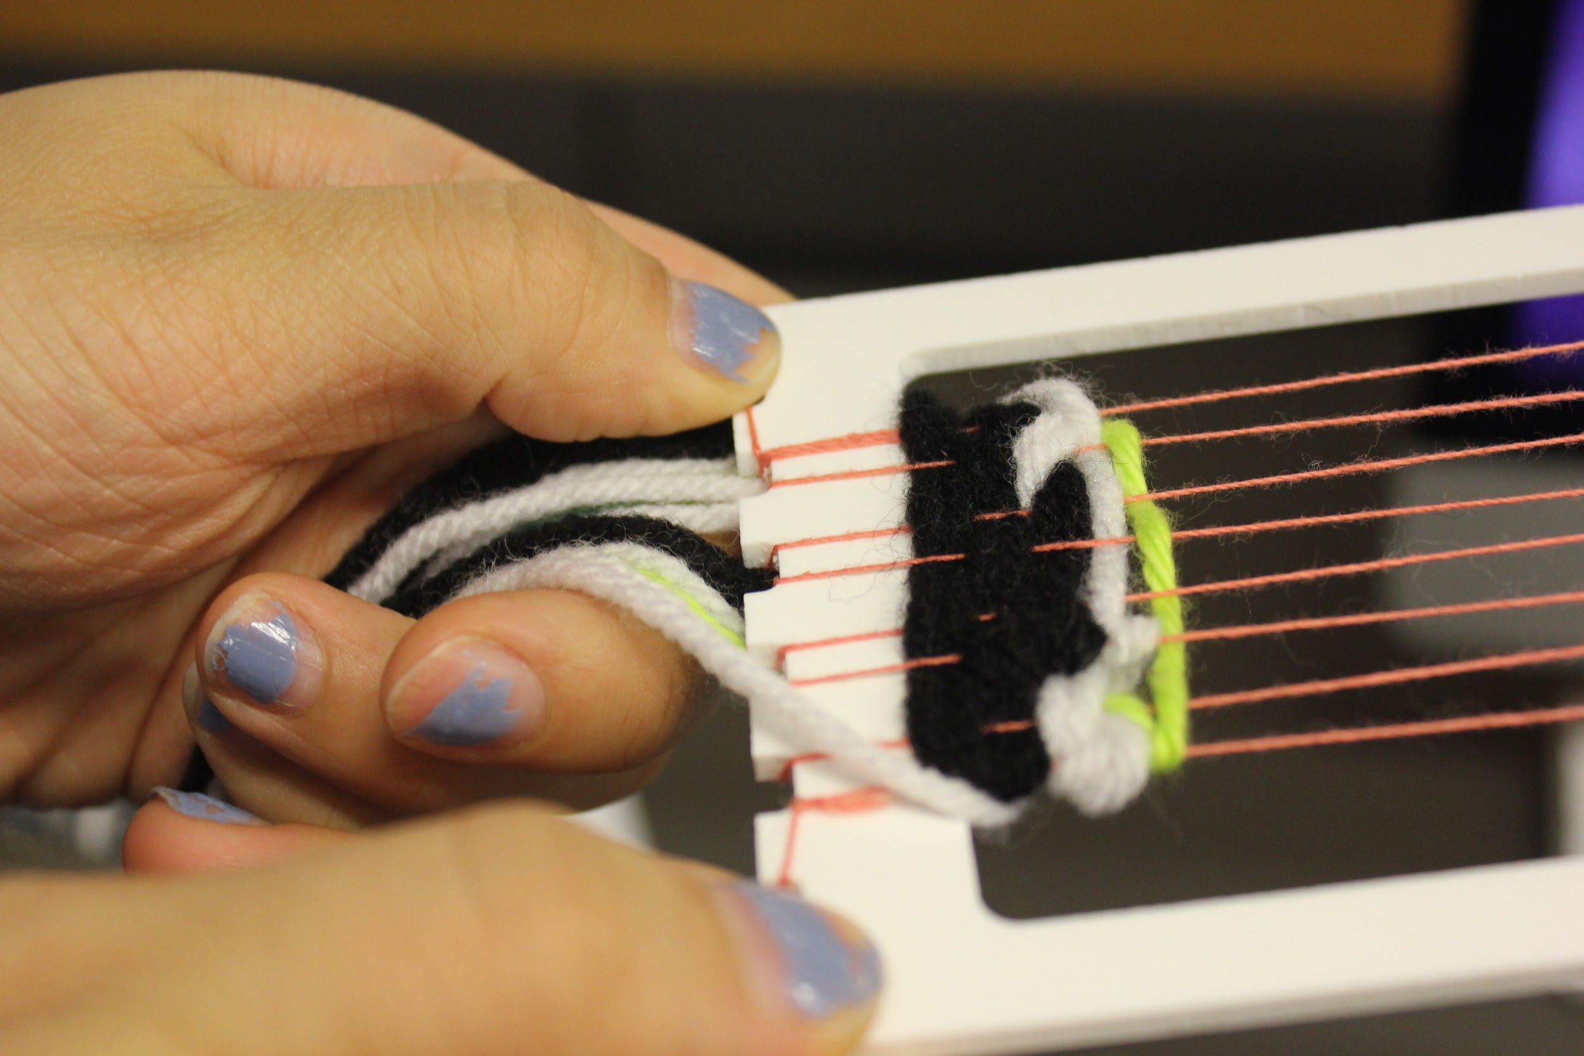

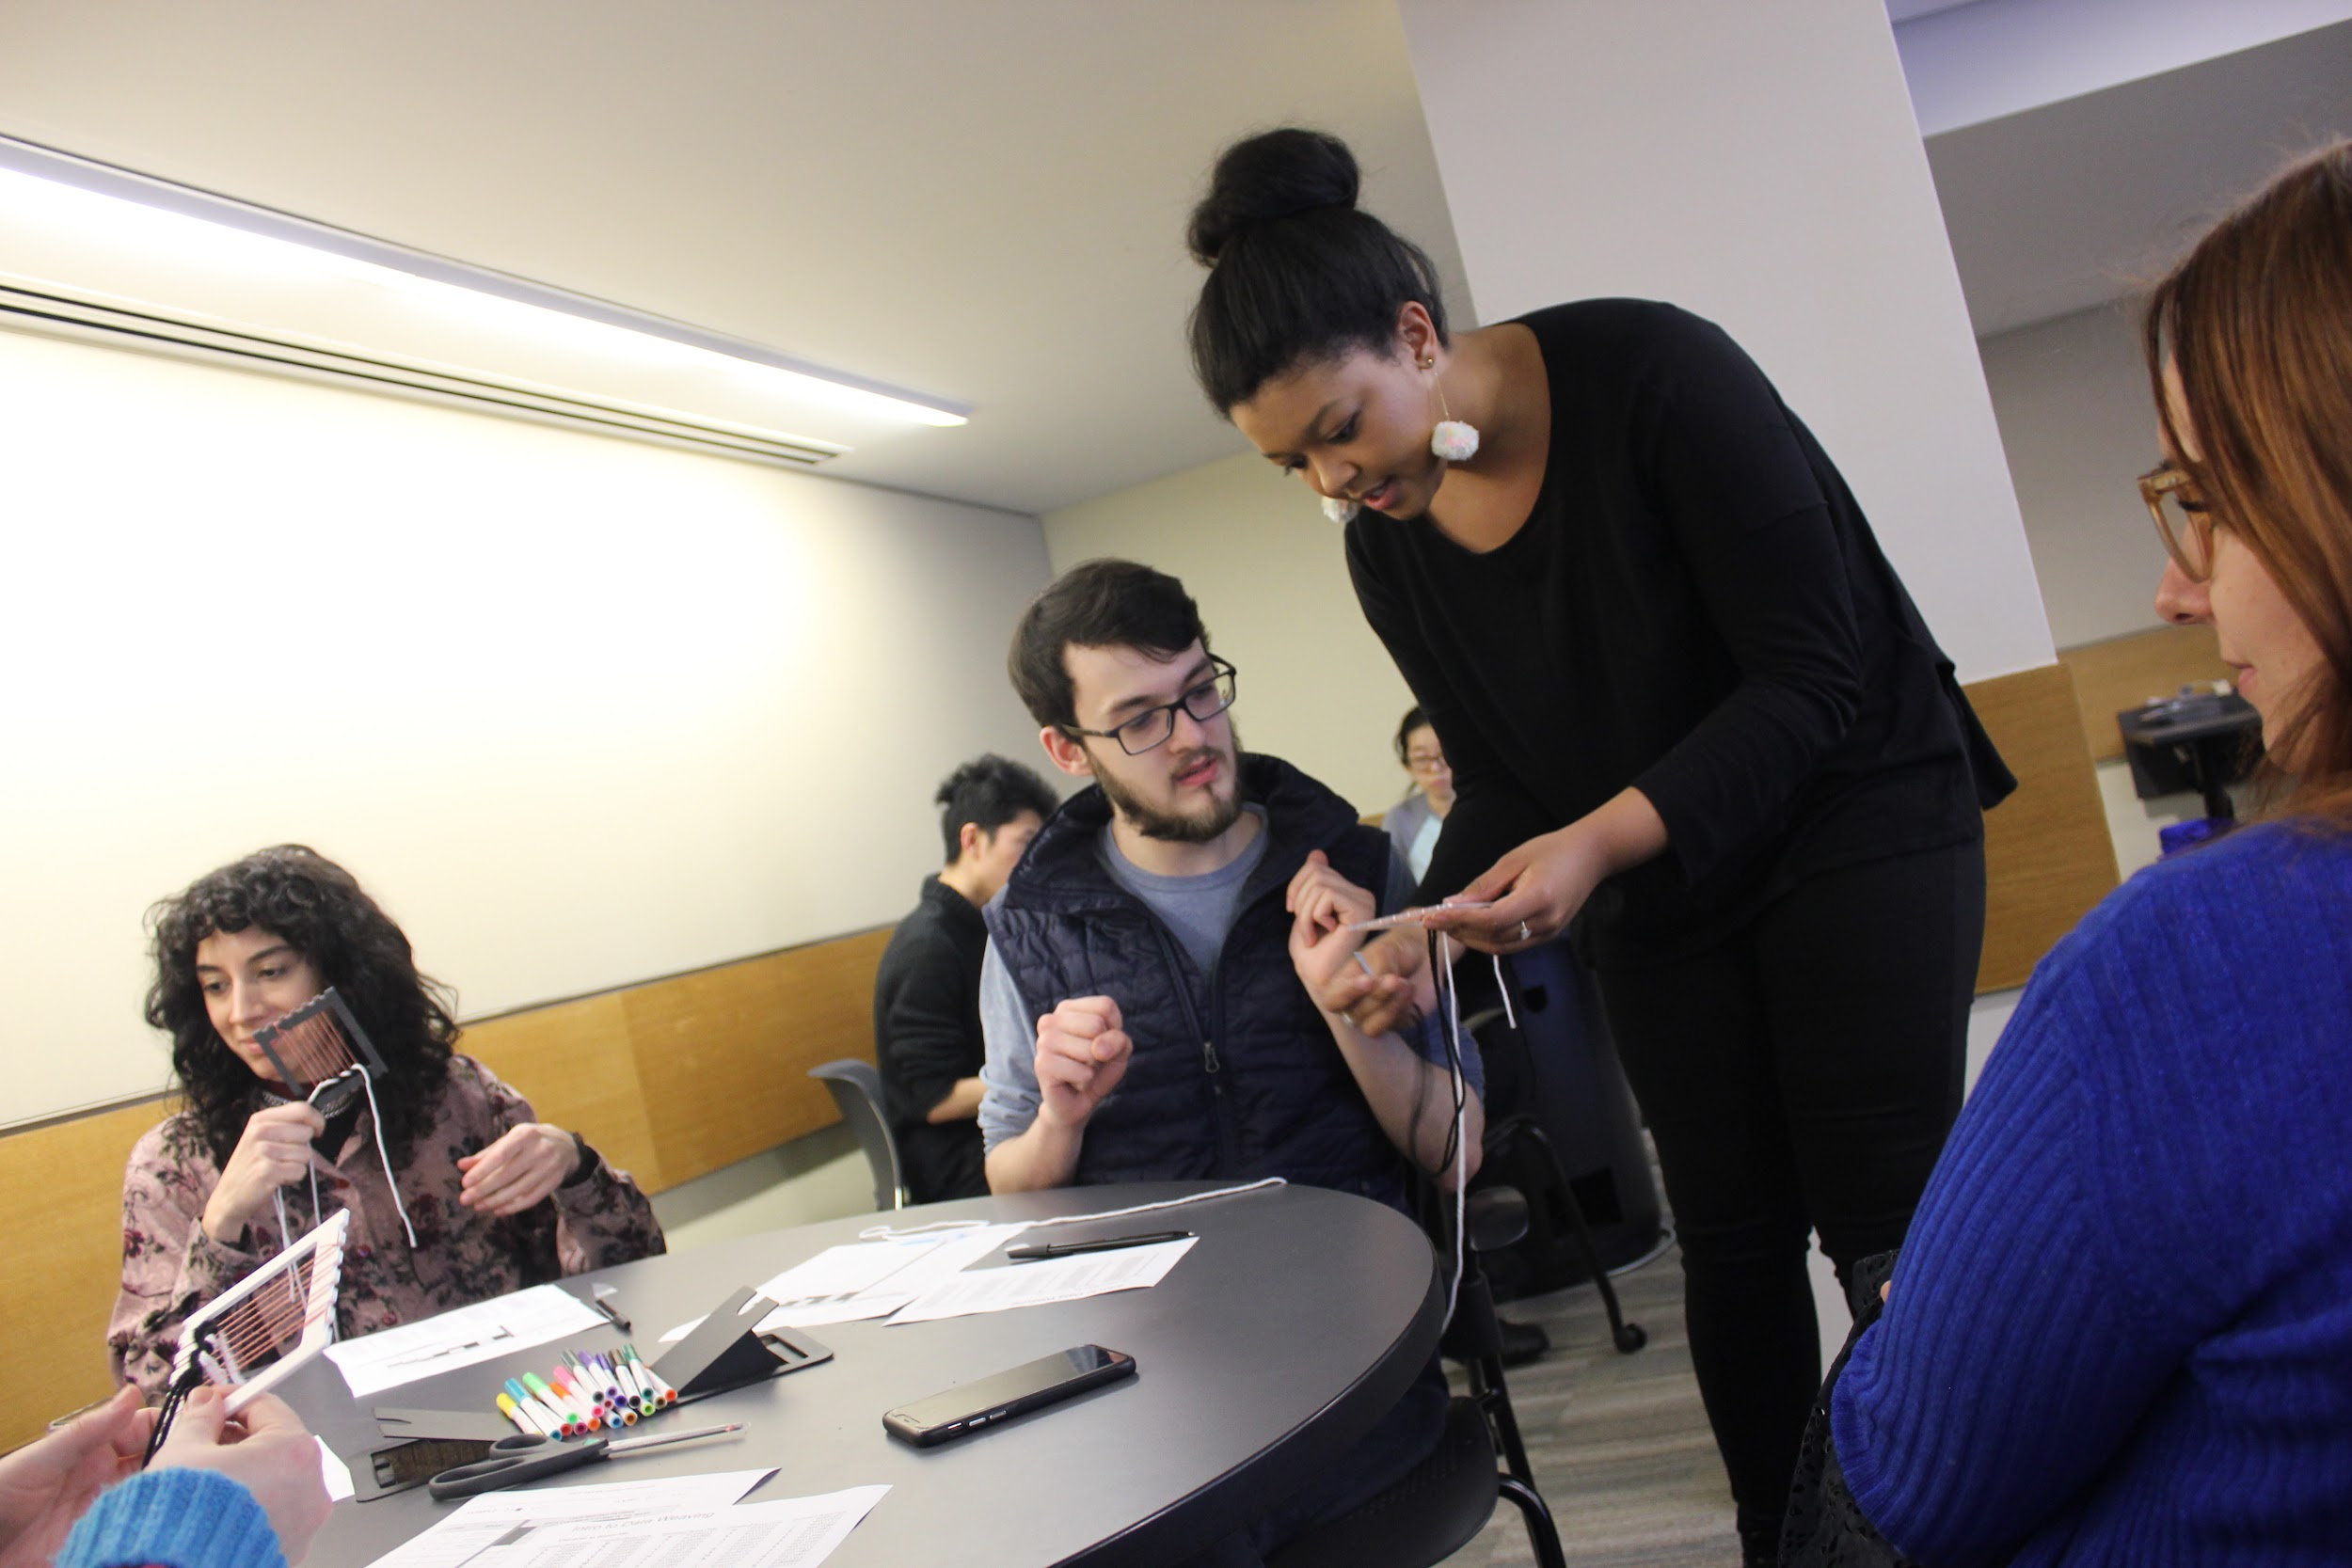

**Teacher Bio**

Ashley Jane Lewis is an Interactive Artist, Maker and Youth Tech Educator. She has exhibited at Band Gallery and Airship 57 and installed at the TIFF Digplayspace (2016 & 2017), The Ontario Science Centre. Her work has been awarded Editor’s Choice by Makezine, Best in Show by Startup Weekend Maker Edition and showcased on the White House website during the Obama administration. Ashley has worked for companies such as Mozilla, Google, NASA, TVO and CBC, to name a few. Through teaching at Ryerson University as well as years of guerilla style workshops, she has had the honour of teaching more than 3000 young women and people of colour how to code. As a result of these efforts, she was listed in the Top 100 Black Women to Watch in Canada in the summer of 2016. Ashley is now studying to get her Masters in Interactive Telecommunications in New York University’s Tisch School of the Arts where she works on Daniel Shiffman’s The Coding Train team to develop and document ml5.js an educational tool for friendly machine learning for the web. [More on her practice can be found here.](http://www.ashleyjanelewis.com)

**Run Your Own Data Weaving Workshop**

As both a demystifying learning tool for computation and a reclamation of the analog, women centered origins of computing, I think all creative technologists so spend some time experimenting with woven data. It helps us stay present with a physical representation of an intangible system. By slowing down our computing it helps us mindfully connect with larger questions like what it means to wear or manipulate data.

Host your own workshop in your city, town or community! This is how I ran mine.

[You can use this folder of resources throughout this tutorial.](https://drive.google.com/open?id=1OniH6NV5mFtOwY3QzZObnsNWSrfYXhHB)

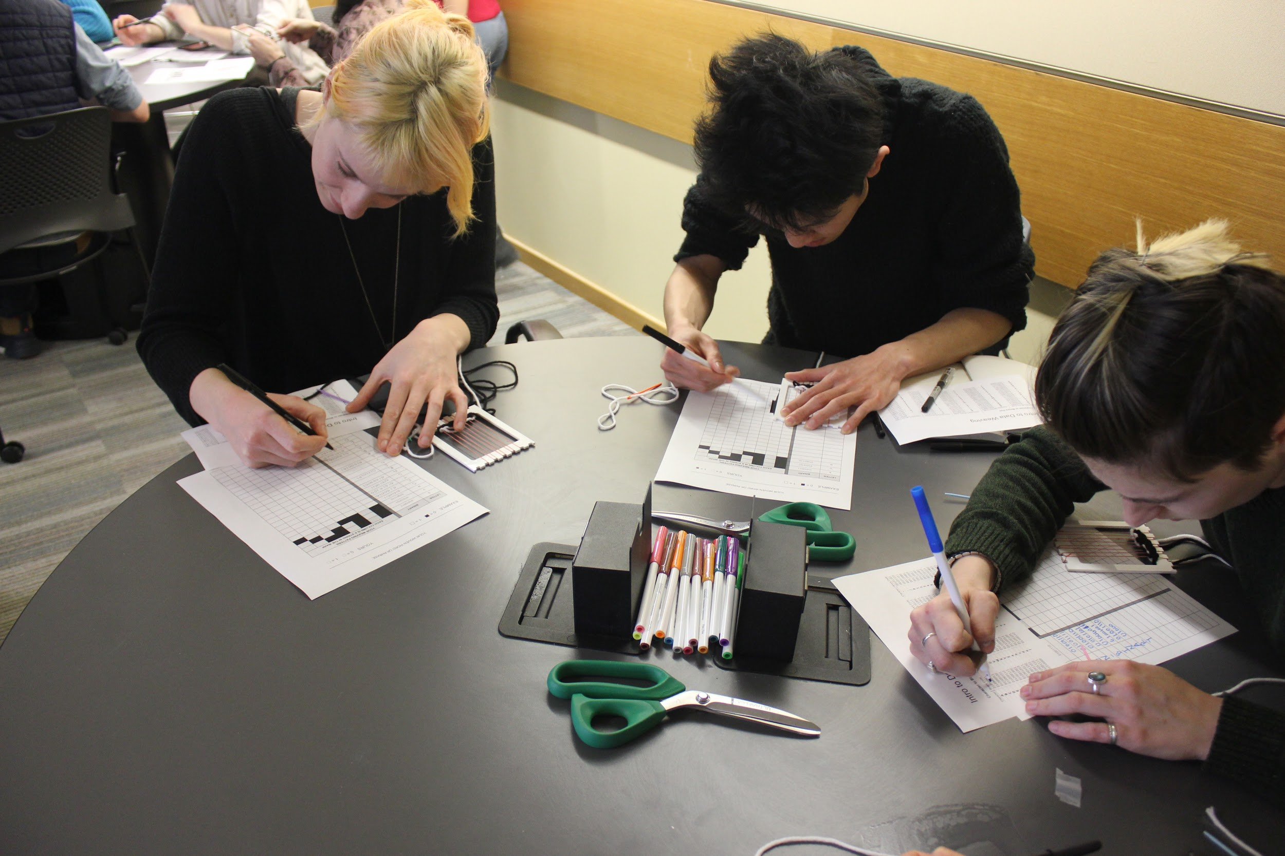

*Two Weeks Before the Workshop*

*Prepping the Tools*

In order to run this workshop, you need to give everyone the tools and allow participants to keep them when the session is over. This creates an open ended nature to the workshop so that attendees aren’t pressured to finish their woven system before the workshop is done.

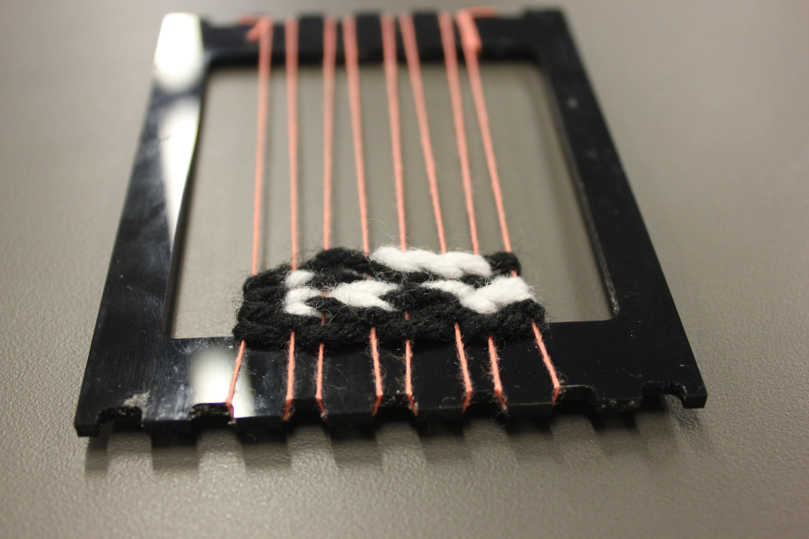

I designed these small pocket looms that would constrain the project to a maximum of 20 lines of binary. I used the other mill to cut my pocket looms but you can use the same file to cut them on a laser cutter or print it out to use as a template to to cut them out with stiff cardboard and an exacto knife.

Download Loom [Othermill](https://drive.google.com/open?id=10fwicFWwAvDgDGCfibE0N42cBINHvifQ) / [Laser Cutting / Template Design File](https://drive.google.com/open?id=1kp-zMiDzxhP9GFRHSSHGAXydvAu8VkGB)

Material needs:

$20 for a sheet of acrylic or $6 worth of cardboard if cutting by hand

*Prepping the Event Details*

I used Eventbrite to create my workshop details. There are lots of other great platforms as well. I shared my event on Facebook and Instagram which made it sell out pretty quickly with both technologists and folks without a digital background. There were even a handful of people just there to observe, or try to snag the seat of a no-show participant.

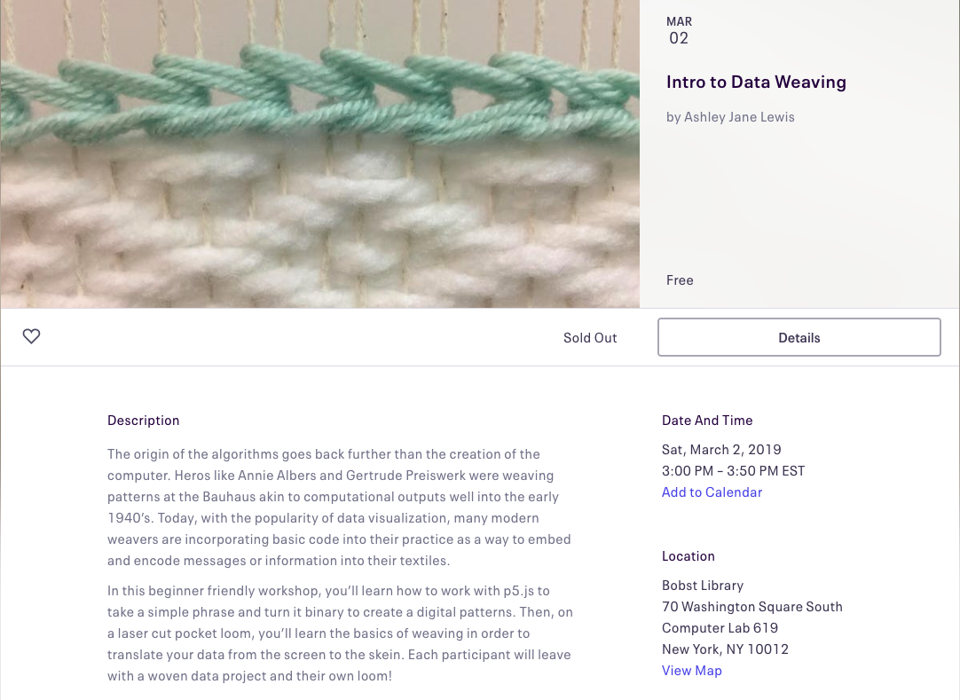

*One Week Before the Workshop*

*Wefting the Looms*

I strung the looms in advance for everyone in the workshop.This part would have been super boring for attendees but would have also been ruined if the strings weren’t taunt. I strung 8 warp strings to hold 8 binary stitches in the weft. Take a look at the [first 56 seconds](https://www.google.com/search?q=warping+a+loom&sa=X&ved=0ahUKEwj3sqbhm_XgAhUhmeAKHUVWBP0Q7xYIKSgA&biw=1309&bih=723#kpvalbx=1) of this video to learn how to string a loom. This would also be a good time to practice weaving with a friend! [You can take a look the latter half of my slide deck for some technique diagrams!](https://drive.google.com/open?id=1yDA8wo602WEEsZB1YcmGReXhIiKa0YWrYE55K1JRuSE)

*Buying the Materials*

I got my materials from Michael’s. The yarn was on sale!

* 10 colours of yarn, approx $3 per skein (get one black and one white skein)
* Markers that match the colours of the yarn, approx $5 x two containers
* Scissors, $5 per pair x 3 pairs

*Printing the Materials*

The students each get two activity sheets. Be sure to print off enough for one per person.

[This sheet is their key or legend for the binary code.](https://drive.google.com/open?id=10Sfz2F9pXRIPlbwuvbeHNcdqkqOyNO6S)

[This sheet is their pattern page.](https://drive.google.com/open?id=1ddpr3poOPEdJLZ7R5k0tPZBZQpW_TVS4) This helps them spell out their desired word and make the pattern from it.

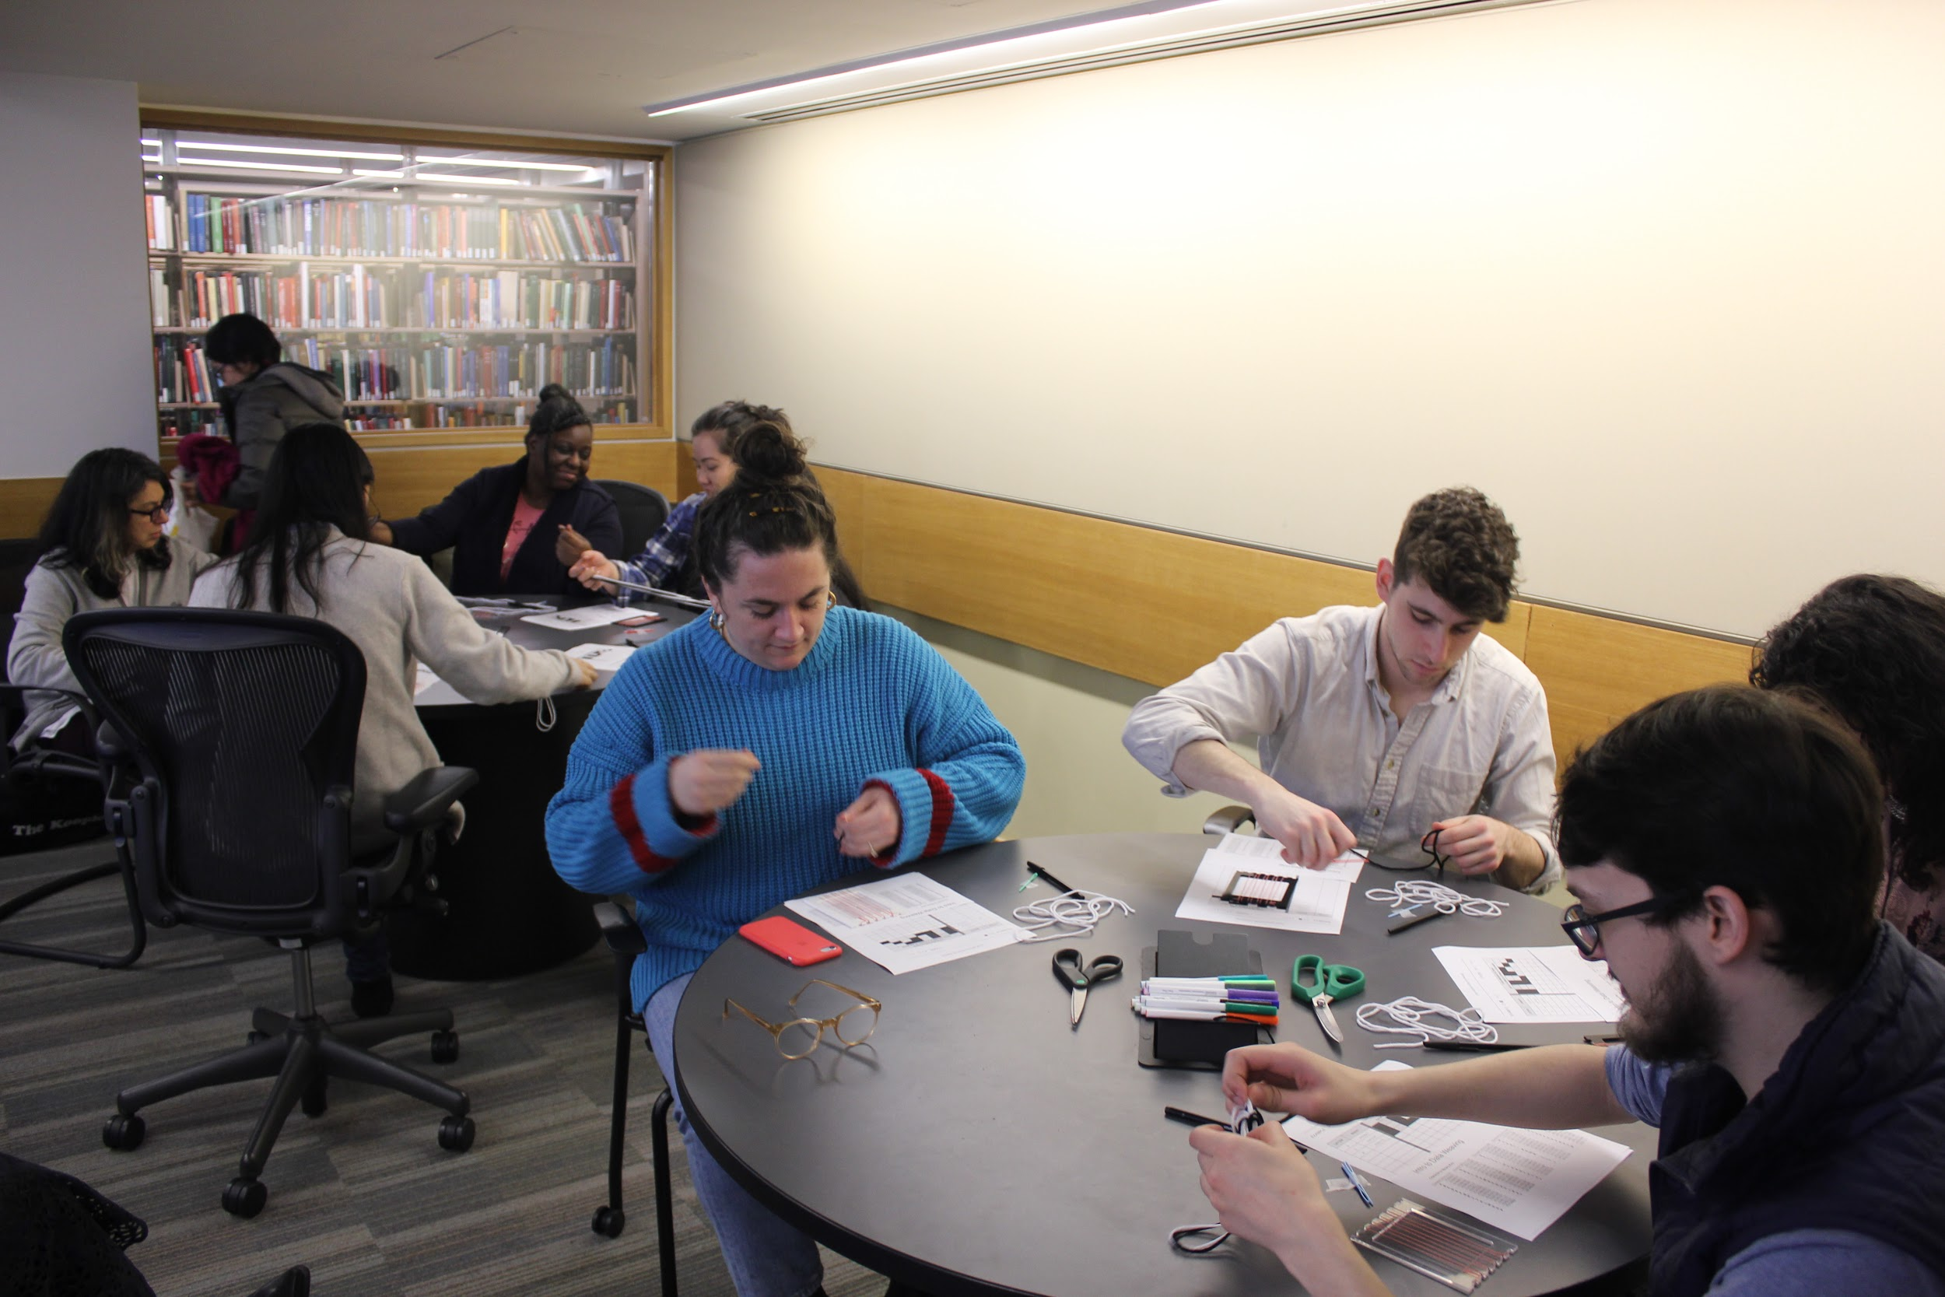

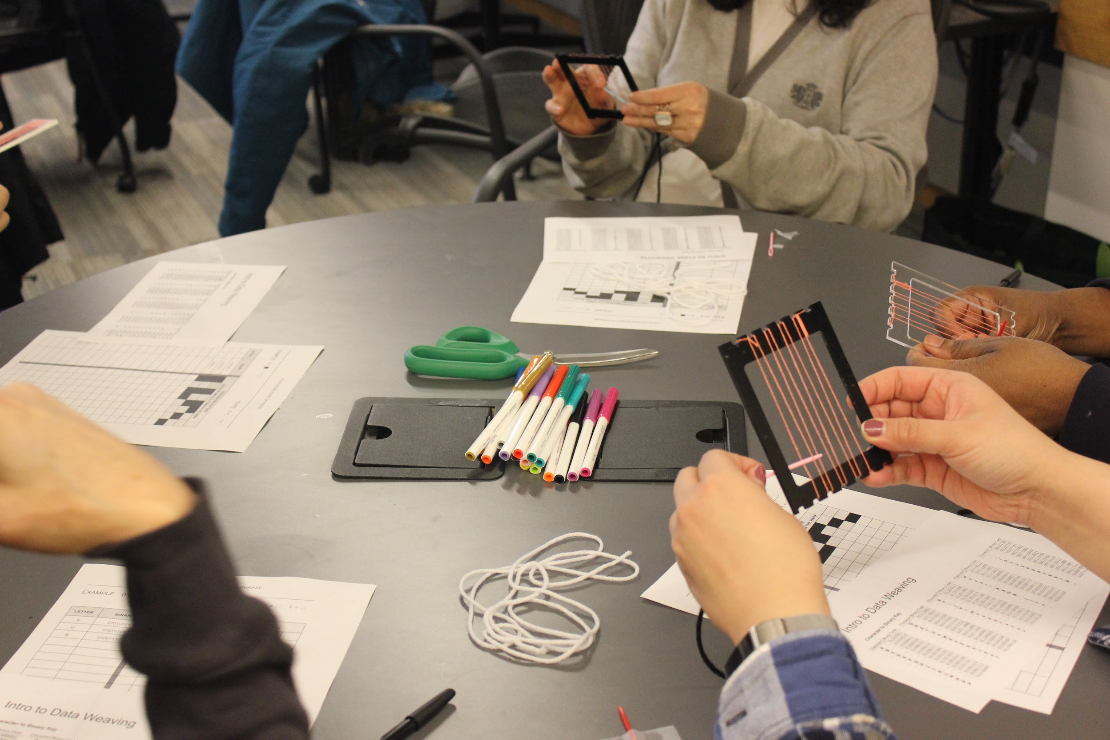

*One the Day of the Workshop*

*Setting Up*

This is the itinerary that I followed:

5 mins - introductions and historical context, with visuals

20 mins - weaving history

30 mins - weaving data

5 mins - concluding statements

My audience was made up of 12 participants and 5 observers, all from a variety of technological backgrounds. It took me about 30 minutes to set up.

Place a handful of markers at each table. At the main table, leave all the yarn. At each station place a loom, two needles, both sheets of paper and a pen. Cut an arms length of white and black yarn and leave a piece of each at each station.

Load [the slide deck](https://drive.google.com/open?id=1yDA8wo602WEEsZB1YcmGReXhIiKa0YWrYE55K1JRuSE) on the projector. The first half of the deck is about contextualizing the origin of computing and aligning it to the loom.

*Reflections*

I asked my participants for feedback via email and in conversation. They we all really happy about the way the workshop went. Most of them wanted a little more time to learn the techniques and almost all of them wanted more time in total. What I really liked was their enthusiasm about the project. One group of women seemed determined to start their own weaving circle which was super exciting!

[Here’s a link to the photos from my event. Good luck!](https://drive.google.com/open?id=1ClNvymcPQDCYsES6W2Mx7X9HbKGRi4Bn)